Clarity Report Library Overview
This document provides a brief summary of the various canned reports in the Clarity system

September 2019
Table of Contents
Accessing the Clarity Report Library 3
Agency Management Reports 4
Agency Specific Reports 5
Data Quality Reports 5
Email Reports 5
Housing Reports 6
HUD Reports 7
Program Based Reports 8
Service Based Reports 12

Accessing the Clarity Report Library
You can access the Report Library in Clarity by clicking the waffle icon in the top right, then selecting Reports.
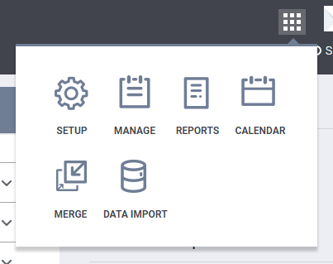
2
1
The Report Library tab lists all the system’s canned reports broken down by category. Click on the category name to open the dropdown and view the list of reports.
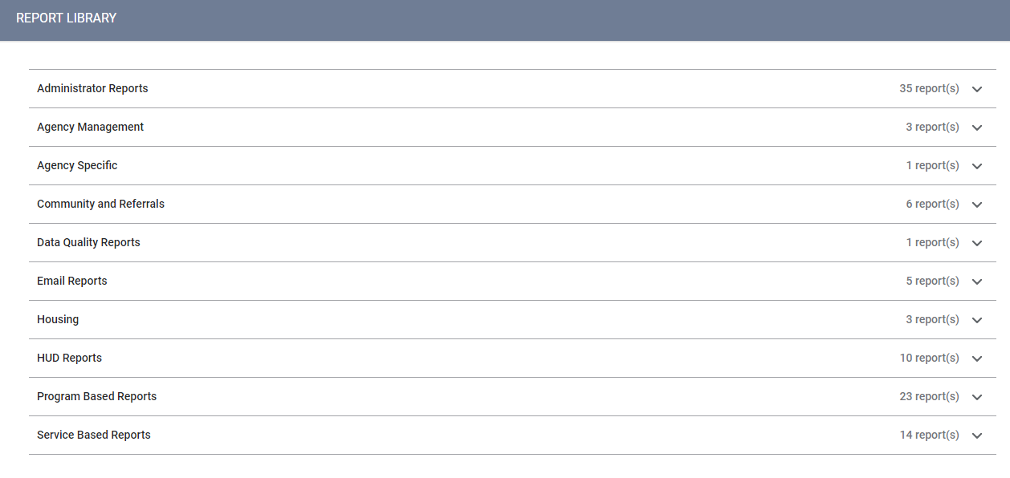

Almost all reports can be printed. If you are given the option to choose a file type and need a print-off, select PDF. This will create a downloadable file that you can open and print normally. If you are only given the option to open your report in a web page, do so, then on the report itself, select File->Print or press Ctrl+P to print the web page. Your printing dialogue should open, and you should be able to print normally. Be sure to check the preview when doing this to ensure that it looks readable before printing!

Agency Management Reports
[STFF-101] User Activity Report
  - Lists all logon and logoff timestamps and session duration information for a user or users. Useful for auditing staff time in HMIS. Note that this can only retrieve data for approximately the most recent 90-day period. Only users with a Manager-level license can run this report.

[STFF-103] User Active Caseload
  - Generates a current list of clients a staff person is currently assigned to as the Assigned Staff within the program enrollment. Useful for reviewing your current client lists and ensuring they are assigned to the correct staff. The Assigned Staff field is listed below. Only users with a Manager-level license can run this report.
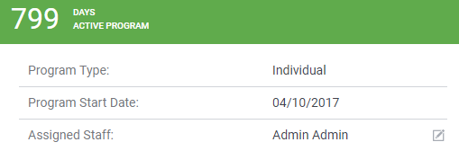
[STFF-104] Staff Client Data Activity Report
  - Allows for auditing various actions within the system for one or more users. Examples include seeing who created client profiles, who enrolled or exited clients from programs, or who uploaded the client’s ROI. Useful for auditing individual users’ actions in the system, or seeing which staff enter which information most frequently. Only users with a Manager-level license can run this report.

Agency Specific Reports
[CO-101] Swipe Card Batch Report
  - A report to quickly print multiple scan cards for clients. Particularly useful in shelter situations, where large numbers of clients are in one spot and need scan cards in one go.

Data Quality Reports
[DQXX-110] Duplicate Clients
  - Generates a list of client records within your agency that are likely to be duplicates. This is done by looking for matches in the name, date of birth, and/or social security number fields. Please note that these are likely duplicates—it is possible for two distinct clients to have the same name and DOB, so be mindful of these issues when reviewing this report. Please contact your HMIS Lead Agency to merge identified duplicate clients.
Please note: DO NOT send client information to the lead agency in an unsecured email—use only the unique identifiers for the records that must be merged.

Email Reports
[DQXX-103] Monthly Staff Report
  - Provides a monthly look at activity in the system for your agency. Includes a breakdown of clients worked with per staff member, inactive staff, and high-level data quality for various fields in the system. Useful to review as a monthly summary of agency-wide HMIS activity. This can be scheduled to be emailed to you on an ongoing basis. Contact your HMIS lead agency for information on how to do this.
[DQXX-105] Monthly Agency Utilization Report
  - Lists all agencies within the chosen CoC, their number of unique clients, and their overall data quality score for a particular time frame. If you are only looking at data for your specific agency, this may not be that helpful for you, as there are better ways to generate more detailed data on an agency level.
[HSNG-102] CoC Housing Assessment Report
  - Provides a monthly housing/bed night attendance average for all shelter programs in the CoC. Also lists the utilization percentage (total beds occupied/total beds available).
[HSNG-104] Monthly Housing Report
  - Returns summary night-by-night shelter information for Emergency Shelter & Transitional Housing programs, including average occupancy, data quality percentage, and unique enrollments for a monthly period.
[HSNG-105] Weekly Housing Census
  - This report is an automated seven-day review of Emergency Shelter & Transitional Housing programs. Displays attendance, data quality, and household size for each date during a given week.

Housing Reports
[HSNG-101] Housing Census [Service Based]
  - Provides a daily listing of attendance in Emergency Shelter & Transitional Housing programs, along with total unduplicated clients served and total services provided.
[HSNG-108] Housing Census [Program Based]
  - Generates a night-by-night count of occupied beds in a program for a specified date range. Useful for tracking bed occupancy over time.
[HSNG-200] Current Housing Availability
  - Generates bed or unit total capacity, total in-use, and current availability for a program. Useful to see at a glance how full your housing programs are. Does not appear to work for night-by-night programs.

HUD Reports
[HUDX-106] HUD Veteran By-Name List
  - Generates a list of veterans in a transitional housing program for a specified date range.
[HUDX-111] HUD CSV / XML Program Data Export
  - Allows you to generate a CSV or XML upload file for a program or programs. While this can also be done from within the APR or CAPER reports, this provides additional options, including encrypting identifying data.
Please note: This report is used to generate HUD CSVs for both SSVF and RHY programs for each respective program repository.
[HUDX-222] Homeless TAY
  - Provides counts of youths age 0-17 and 18-24 entering a program or programs during a specified date range.
[HUDX224] PATH Annual Report
  - Generates the PATH report for a specified date range.
[HUDX-225] HMIS Data Quality Report
  - Generates the data quality report for a program or programs for a specified date range. The in-browser/web page report is particularly useful here, as the drilldown function allows you to resolve data quality issues in real time.
[HUDX-227] Annual Performance Report (APR)
  - Generates the HUD-required annual performance report for a program or programs during the specified date range. For more information, please watch our APR tutorial video.

[HUDX-228] ESG CAPER
  - Generates the HUD-required CAPER for a program or programs during the specified date range. For more information, please watch our ESG CAPER tutorial video.
[HUDX-231] LSA Export
  - Generates the longitudinal systems analysis CSV for one or more programs in one or more CoC agencies during the specified date range.

Program Based Reports
[DQXX-102] Program Data Review
  - Provides a roster either of active or exited clients, with their entry/exit dates and days active in a program or programs. Also indicates if entry or exit data is missing.
[DQXX-121] Project Start Date > Project Exit Date
  - Will list any enrollments in your agency where the project start date is after the project exit date. This should happen infrequently, as the system will stop you if you attempt to exit a client prior to their entry date.
[EMPL-101] Employment Report
  - For housing programs with connected employment placements, this report will list employment history for clients in the program during the specified date range. This does not list employment history from the client profile or program enrollment screens.
[EMPL-102] Employment / Education Report
  - Provides employment and education status of active or exited clients in a program or programs during the specified date range.

[EXIT-101] Potential Exits
  - Lists clients active in a program or programs that have not received services since a specified cut-off date. Useful for identifying clients that are not being actively served for exiting from the program.
[EXPS-102] Program Service Expense Review
  - Provides information on service expenses (e.g., bus tokens, food assistance) connected to funding sources, during the specified date range. Runs for all programs in your agency.
[EXPS-103] Program Funding Source Financial Detail
  - Provides a listing of financial sources (typically attached to services) for a particular date range. Useful if your program actively tracks dollar amounts distributed to clients.
[GNRL-105] Program Participation Summary
  - Lists clients enrolled in a program during a specified date range, along with total number of assessments and services provided.
[GNRL-106] Program Roster
  - Provides a roster of clients either active, enrolled, or exited from a program or programs during the specified date range. Please watch our Program Roster tutorial video for more information.
[GNRL-115] Length of Stay at Prior Living Situation Comparison
  - Returns the length of stay in prior, less than 7 nights, and less than 90 days questions for clients active in a program or programs during the specified date range. This is a type of data quality report to resolve discrepancies between these three questions—e.g., client indicated staying 2-6 nights in prior situation, but answered no to less than 7 nights.

[GNRL-220] Program Details Report
  - Generates a zipped Excel file listing answers for various screens (e.g. entry, exit, assessment, etc.) for a program or programs during the specified date range. Useful for determining whether all enrolled clients meet the eligibility criteria for a restricted program—e.g., PATH clients must have a mental health condition to be enrolled; this report can determine whether everyone in the system meets that criteria.
[GRNL-230] Program Group Income
  - Lists income amounts either at program entry or latest assessment for clients active or enrolled in a program or programs during the specified date range. This does not list income sources, only amounts. Useful to view program-wide income levels.
[GNRL-240] Program Household Served Report
  - Lists counts of total clients and total households, further broken down by household size, for a program or programs during the specified date range. Useful to quickly get a sense for overall household composition for a given program.
[GNRL-242] Client Project Stay Issues
  - This report can help to identify problems created using the Data Integration/File Upload tool. Please refer to Bitfocus’s support article for more detailed documentation on what each error means.
[GNRL-241] New vs. Re-Entry Client Program Classification
  - Lists new and re-entered (i.e., a client enrolled and exited from a program, subsequently re-enrolling) in a program or programs during the specified date range. Useful, as an example, for shelters tracking numbers of new or returning overnight stays night-by-night.

[GNRL-247] NOFA CoC Project Data Query
  - Generates tables of disabled and non-disabled individuals affected by various conditions on the entry screen, e.g. substance abuse, severe mental illness, DV victims, etc. Used to help populate NOFA numbers.
[GNRL-400] Program Linked Service Review
  - Returns all services linked specifically to a program or programs during the specified date range. This differs from the service-based reports in that it will filter out services added from within a program enrollment only, rather than services added to the client profile generally.
[JRSD-104] Zip Code Jurisdictional Breakout
  - Provides counts of individuals and families active in a program or programs broken during the specified date range, broken down by zip code.
[OUTS-101] Program Outcome Measures
  - Provides summary-level outcomes data for clients exited from a program or programs during the specified date range. Includes destination counts, income information, and length of time to obtain housing. Useful to get a high-level sense of client status upon exit.
[OUTS-102] Performance Monitoring
  - Provides percentages of clients active in a program or programs, during a specified date range, that meet various “harder to serve” criteria, such as mental illness, HIV/AIDS, or domestic violence, as well as income information and data quality. Points are awarded for each category; the intent is to objectively score the program, but at this time, the points fields are all blank.
[OUTS-106] Client Demographics
  - Generates tables and graphs breaking down client demographics for a program or program, filtered by active/entering/exiting the program during the specified date range. Summaries include age, gender, race, disability, veteran status, prior living situation, income, and SSN validity.
[OUTS-205] Program Recidivism
  - Provides counts of exits, and whether the exit was to a permanent destination or back to homelessness, for a program or programs during the specified date range. Useful to quickly determine positive vs negative destinations on a program level.
[OUTS-720] Client Program Service
  - Lists all services provided within program enrollments for a program or programs during the specified date range, grouped by client. Note that this does not list service dates, only names.

Service Based Reports
[EXPS-101] Financial Source Funding Detail
  - Provides details of your agency’s funding source(s) (primary and/or sub-granted funding sources), including a detailed history of their associated service transactions for a specified date range.
[GNRL-102] Client List
  - Generates a list of clients who have received one or more specific services (across all programs) during the specified date range. Useful for looking at the frequency of particular services over time.
[GNRL-103] Service Census
  - Provides a day-to-day breakdown of the number of times one or more specific services (across all programs) were provided during the specified date range. Differs from the Client List in that it does not provide identifying information, and displays total services provided per day rather than broken down by client.

[GNRL-104] Service Summary
  - Provides counts of unique clients, total number of services provided, and service days (unique clients multiplied by services provided) for a specific service or services for the specified date range. Useful for tracking the frequency and volume that a particular service was provided during a monthly, quarterly, or annual period.
[GNRL-111] Attendance by Days Served
  - Reports the total number of days that a service was entered per client for a specified date range. For example, if case management was entered for a period of 5/1/2019—5/31/2019, this report would list those dates along with 31 total service days.
[GNRL-112] Client Address / Location
  - Reports address and location information, from the client’s Location tab, for all clients that received a specific service or services during the specified date range. While this can be helpful for getting a list of contact information, it may be easier to build this report in Looker.
[GNRL-210] Assessment Details Report
  - Lists all responses to the questions on the selected assessment. The responses for each client are included. Only available in Excel format.
[GNRL-211] Service Issuance Summary
  - Provides a summary of service issuances for a chosen service during a specified period of time. Provides summary, client list, and totals data for the chosen service.
[GNRL-212] Profile Details Report
  - Lists all responses to questions on selected profile screen. Only available in Excel format.

[GNRL-403] Public Alert Notice
  - Returns all clients with an active service placement that have a Public Alert listed in their profile. Useful for generating a list of individuals with some sort of acute actionable item. The date parameter here is for the service date; running this will only return clients with alerts if they received a service during the specified date range.
[JSRD-103] Zip Code Jurisdictional Breakout
  - Equivalent to the Zip Code Jurisdictional Breakout in the Program Based Reports section but run for a service instead.
[OUTS-105-F] Client Demographics (Flat version)
  - Generates tables breaking down client demographics for a service or services. Similar to the Client Demographics report in the Program Based Reports section, but without the graphs, and chosen per service rather than per program.
[OUTS-105] Client Demographics
  - Equivalent to the Client Demographics report in the Program Based Reports section, but for a service rather than a program.
[OUTS-107] Households Served Report
  - Provides a listing of all households that received a particular service or services during the specified date range. Note that this does not return client-level data, only aggregate counts of households served.

